VANGUARD TRIKE DESCRIPTION ITEMS AND PRICE.

OPTION 1 BASIC STYLE 5950,25 USD – NO ENGINE & PROPELLER
A- Description
- Unique trike with three types of interchangeable pilot baskets or flight modes: 1. Commercial, 2. Adventure, and 3. Reportair. All are interchangeable, making your trike a three-in-one.

- ADJUSTABLE CENTER OF GRAVITY IN FLIGHT: A unique system in the world that allows you to deploy a parachutist and adjust the center of gravity from tandem (double) to single in mid-flight. This provides the pilot with the confidence to continue flying in single position and safely land.

- Designed for versatility and safety that protect pilot and passenger, The pilot sits is several centimeters above the passenger, ensuring excellent visibility in flight. The harnesses are very comfortable, and the pilot has access to instruments without obstructing visibility. It includes a water pocket (camel-back), Its main strap can hold a weight of 4 tons, and it has two additional sets of backup tethers in case of failure, providing two layers of protection. Its suspension is active and independent. The passenger feet never interfere with taxiing.

- FUEL TANK 17 GAL: This container is made of 3mm plastic, resistant to UV rays and gasoline. Its ergonomic design, shaped like a seat, keeps the center of gravity fixed as fuel is consumed. Its volumetric capacity is considerable, and with the option of white or black, it has an analog sight on the right side with a gauge in liters. Its "R" reserve has a volume of 8 liters to give enough time to maneuver for approximately 1 hour.

- TWO HARNEES: Its special attention to ergonomics allows for long flights without fatigue. The passenger harness is designed to provide extra passive protection because the passenger travels in a fetal position. It is easily accessible, and the passenger's feet do not interfere with the pilot's taxiing.

The pilot harness is positioned in an ergonomic driving position with enhanced visibility because the pilot is positioned above the passenger. It also provides access to instruments and hydration by adding a water bladder or CamelBak. All harnesses are hung for passive safety and are very easy to access and detach since they only have one certified Cobra fastening buckle for easy exit in case of emergency.

- MAIN STARPS : The main harness is a 2-inch harness with a 4-turn loop to quadruple its strength. It comes in two sizes: one so the carabiner is below the gravity control system, which improves comfort because the pilot's hands aren't raised as high since the controls and wing control system are lower and more accessible, thus reducing strain on the rotator cuff of the shoulder; and the other system, which places the carabiner above the gravity control system, is the standard configuration used by other companies, and some pilots are accustomed to this system.

- HAND THROTTLE: The manual throttle has a long lever to reduce hand strain, as the engines have two carburetors. It has a kill switch system that is readily available for easy replacement. However, we recommend adding our engine electrical system, which is already well-tested. If the engine has dual ignition, the kill switch does not connect the grounds, allowing each magneto and spark plug to work independently.

- ONE ENGINE MOUNT FOR ROTAX 503, ROTAX 582, HIRT SERIES 35 OR SIMONINI VICTOR 2: Our exclusive engine mount is independent and has three layers of anti-vibration: 1) raised aluminum plates, 2) engine support bushings, and 3) an independent engine band mounted on nylon bushings and bolts. All of this reduces vibration transmitted to the pilot.

ALL THIS CARACTERISTICAS ARE BY DEFUAL IN OUR BASIC TRIKE. 5950 USD

SECCION DE CUSTOMIZACION

1-CHOSE A COLOR
(DEACUERDO AL COLOR ELEJIDO LAS FOTOS DEBEN CAMBIAR POR EL COLOR ESCOJIDO)

- RED CANDY AND WHITE.
- BLUE CANDY AND WHITE
- PURPLE CANDY AND WHITE

2- Chassis. CHOOSE YOUR FLYING STYLE
A-(CAMBIAR POR ESTE TITULO)
B- como esta dividido en dos secciones, la sección que esta en verde debe tener 3-4 fotos y que se pueda ampliar cada FOTO dando un clip o como lesquede mas fácil HACER ESTE PROCESO, pero que sa fácil para el usuario, en la sección de la derecha debe estar el modelo 3D ya que será la sunda etapa de este proyecto.
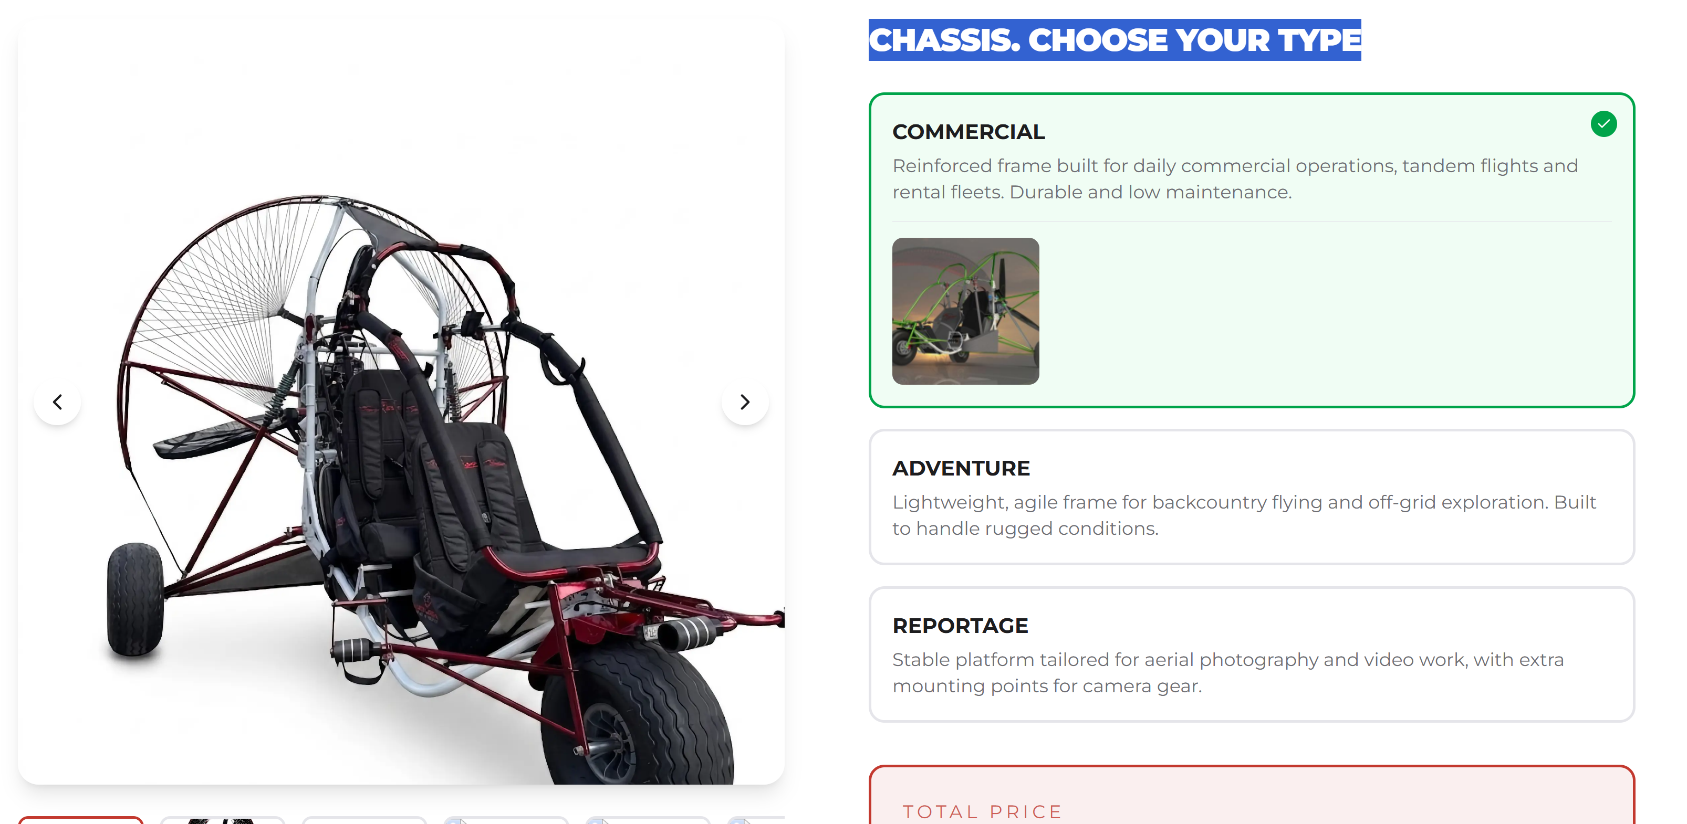
B-AL MOMETO DE HACER EL 3D EL DISENO DEBE CAMBIAR DEACUERDO DE ACUERDO AL TIPO DE VUELO ESCOJIDO (COMERCIAL, ADVENTURE O REPORTAIR).

- COMERCIAL: Designed for tandem flying, the passenger has easy access from the front. The passenger harness is comfortable and positions the passenger deep inside the trike, providing safety as their head is below the bars. The passenger's foot support does not interfere with the pilot's taxiing. This type of trike allows for the attachment of accessories such as a bar protector with a special padded handle for the passenger.

- ADVENTURE : Designed for pilots who want to fly far and fast, its dynamic style allows for more penetration and less drag, making the wing more efficient. This type of flight is ideal for adventurers, and

- REPORTAIR: Designed for maximum passenger visibility and the exclusive option of mounting a camera with a rotating bracket. Also, if you enjoy hunting, you can add a weapon mount, as the passenger will have full access to the right or left side.

3- ENGINE
- CADA MOTOR DEBE TENER SUS TRES O 4 FOTOS EN LA SECCION VERDE Y LA DESCRIPCION DEL MOTOR JUNTO CON UN LINK PARA BRINDAR MAS INFO SI EL CLINTE LO DESEA. ADICIONO EL LINK PARA COLOCARLO EN LA DESCRIPCION, CADA FOTO DEBE SER AMPLIABLE COMO ACORDAMOS.
- A LA DERECHA SE DEBE COLOCAR EL MODELO EN 3D CON EL MOTOR ELEJIDO PARA SEGUNDA ETAPA DE ESTE PROJECTO.
- EL PRECIO DEL MOTOR DEBES DARME LA OPCION DE CAMBIALO DE MANERA FACIL . YA QUELO PRECIOS ESTAN POR COREGIR YA QUE ESTOY TRAMITANDO SER DEALER.

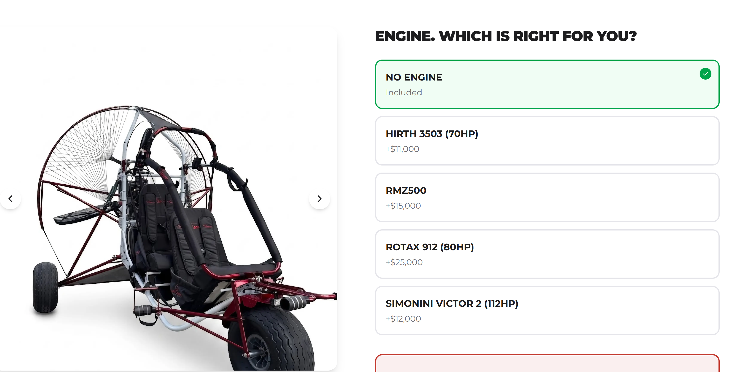

- HIRT 3503 7O HP: The 35 Series liquid cooled two-stroke engines offer the maximum power-to-weight ratios available in the 70-horsepower market.
Offers an ideal choice for use in light and ultralight aviation, hovercraft, gyro and helicopters and all applications where weight could be an issue.
This engine series offer a time between overhauls of 1000 hours at 75% power and is fit to take on any challenge in the future.
LINK:
https://hirthengines.com/3503-liquid-cooled-70hp-two-stroke-engine/

- Información pro confirmar A QUE ALPARECER LA FABRICA EN RUSIA NO LO VOLVERA A PRODUCIR POR TEMAS DEL LA GUERA. (PORFAVOR HACER EL COMENTARIO EN LA PAGINA)
RMZ500 (ROTAX 503 CLON) he RMZ 500 is a 497cc, two-stroke, twin-cylinder air-cooled aircraft engine built in Russia. It serves as a direct, compatible clone of the classic, out-of-production Rotax 503 engine, producing roughly 50 to 52 horsepower at 6,000 rpm and weighing about 34 kg (75 lbs).

- SIMONINI VICTOR 2: A powerful, very reliable and lightweight two-stroke engine weighing 52 kg with an excellent TBO of 1200 hours. Its great power means it is not necessary to have the engine at high RPMs. Its static thrust reaches 160 kg, which makes it very impressive.
LINK
https://www.simonini-flying.com/en/home/127-victor-2.html

- ROTAX 912: The Rotax 912 UL | A | F is an 80-horsepower (59.6 kW), four-cylinder, four-stroke aircraft piston engine featuring a hybrid liquid/air-cooling system, integrated reduction gearbox, and dual electronic ignition. The designation covers uncertified and specific airworthiness-certified variants used widely in light sport and experimental aviation.

LINK
https://www.flyrotax.com/products/912-uls-s

4- PROPELLERS
1. Colocar fotos y descripcion lo mismo cada foto se debe ampliar y en la descricin colocar el link .
2. SI ELIJE MOTOR SIMONINI VICTOR 2 SUPER, ROTAX 912 EL PRECIO DE LAS HELICES SUVE 300 DOLOTRES EN THREE BLADE Y 250 EN TWO BLADE
- Helis propeler Two Blade: H40F (UP TO 47KW) DIAMETER 165CM OR 64.9 IN IS ESPECIAL BUILD FOR ENGINES ROTAX 503, 582, RMZ500 PARA TRIKES
When you need the extra push of a larger motor, our 47kw propeller variants are the be-all-and-end-all monsters of the paramotor world.
- TRE BLADE H40F (UP TO 47KW) DIAMETER 165CM OR 64.9 IN IS ESPECIAL BUILD FOR ENGINES ROTAX 503, 582, RMZ500 PARA TRIKES , reduce noice and increase 2% more of static trust. When you need the extra push of a larger motor, our 47kw propeller variants are the be-all-and-end-all monsters of the paramotor world.
Link :
https://helix-propeller.de/propellers/paramotor/

This info is for engines simoni victor 2 super & rotax 912
- Two blade for engines simonini victor 2 super & rotax 912 UL | A | F:
DIAMETER 165CM OR 64.9 IN , Lightweight design makes Helix propellers easy to install- even for one person. The inherent compact nature of the blade roots makes transport and storage a breeze.
Three blade propeller: DIAMETER 165CM OR 64.9 IN IS ESPECIAL BUILD FOR ENGINES ROTAX 912 80hp & Simoni Victor 2 super 110hp, reduce noice and increase 2% more of static trust. Lightweight design makes Helix propellers easy to install- even for one person. The inherent compact nature of the blade roots makes transport and storage a breeze.

El link es para las dos hélices tri-blade u two Blade las fotos las puede bajar de ese link.
Link
https://helix-propeller.de/propellers/airplane-gyro-trike/fixed-pitch-propellers/

5- ACCESSORIES. ENHANCE YOUR FLIGHT.

- Porfavor colocar esta lista en este orden
- En la caja verde la sección que esta en verde debe tener 3-4 fotos y que se pueda ampliar cada FOTO dando un clip o como les quede mas fácil HACER ESTE PROCESO, pero que sa fácil para el usuario.

- RESERVE PARACHUTE
Para este producto utilizer las fotos de este link:
https://aviatorppg.com/catalog/paragliders/reserves/apco-mayday-ul-reserve/

The APCO Mayday UL28 Reserve………………………………….$1528 USD.
certified for heavy trike flying and light enough for real adventures. Built for the kind of pilots who go farther, carry more, and refuse to compromise.
Apco Aviation started manufacturing the Mayday in 1984, and since then put over 40,000 pieces into service in the Paragliding and Hang Gliding markets. The Mayday has hundreds of life saving deployments to its name, from beginners to world champions.
Now we are proud to introduce the MAYDAY 28 UL, a new pioneering emergency parachute, specially designed for trikes – single and tandem.
Mayday 28 UL capable of safely handling loads of up to 400kg. Formally load tested by EN approved laboratory – Air Turquoise – confirming safe opening and descent with maximum load of 340 kg. Tests were carried out at opening speed of 40m./sec. as per standard EN requirements for emergency parachutes.

- PARACHUTE CONTAINER……………………………………. $65 usd:
Made of materials that are highly resistant to sunlight, abrasion, and lightweight, perfect for being placed on the right or left side of the pilot's harness, allowing for easy deployment if necessary.

- VANGUARD SUNSHADE NET OR SUNSCREEN…………………………………. $43 USD
This system also protects the pilot from the sun, especially when the paraglider is descending sideways, preventing the lines from tangling with the helmet or other trike equipment.
- PADDED ROLL BAR PROTECTOR WITH HANDLES……………. $47 USD
It protects the passenger and provides more comfort thanks to its handles; additionally, the front bars are padded, making the trike look more robust.
- FRONT BRAKE……………………………………………………….. $120 USD
An additional cable brake provides extra braking power; this system is conventional and comes from mountain bikes.
- REAR MIRROR …………………………………………….………… $25 USD
Essential for viewing the wing's position in its first quarter of lift during takeoff, providing precise information about the wing's position when it's behind the trike, lying flat.
- VANGUARD PROTECTOR COVER…………………………….. $105.00 USD
A well-designed accessory to protect your trike. You can carry it on your trailer and avoid creating drag, as it only covers essential parts like the passenger/pilot cabin and engine. It does not cover the propeller ring.
- VANGUARD TWO (2) SIDE EXPLORER CASE (L-R) ……………………………... $95 USD
Adventurer's case with extra straps for attaching fishing rods, tents, fuel, etc., to the outside of the case without taking up internal space. This case is aerodynamic to reduce drag.
- CRUISE CONTROL………………………………………………….. $25 USD
For those who enjoy long-distance flights and want to relax their hands and shoulders, this system easily connects to the motor to maintain the desired RPM for a stable and smooth flight.

- VANGUARD Fuel gauge …………………………………. $114.5 usd
The fuel gauge, with an analog clock that approximately indicates the amount of fuel since the tank is L-shaped, when it reads empty it is actually on reserve with 10 liters in reserve to have the necessary time to maneuver and land.

- AUXILIARY LIGHTS………………………………………………….187.1 USD
Includes: two (2) UP67 50,000 watt waterproof LED lights (4 functions: white, yellow, and strobe: white and yellow), two (2) red and green LED position indicator lights (strobe light), luxury switch with LED light, 10 meters of #2x18 cable, 4-pin relay and its base, 4 quick connectors for #2x18 cable; all installed inside the structure with cable glands and connected to the panel for later installation to the electrical system of the selected motor. It is HIGHLY RECOMMENDED TO ADD THE MOTOR'S ELECTRICAL INSTALLATION (USD 218.)

- BASIC INSTRUMENTS KIT …………………………………………$340 USD
includes: TTO digital RPM tachometer, TTO digital spark plug temperature gauge, TTO digital engine coolant temperature gauge, USB charger (4 ports). HIGHLY RECOMMENDED TO ADD THE ENGINE INSTALLATION KIT (218.2 usd) to ensure everything works correctly and to easily install the engine on your new trike.

- COMPLETE ELECTRICAL INSTALLATION KIT FOR SELECTED ENGINE, includes: 12V current regulator/rectifier, 12V relay and connector base for dual-ignition engine shutdown, 4-pin relay for auxiliary light contactor, 12-amp starter solenoid, two engine magneto test buttons, toggle switch with protector (master), 7-amp industrial push-button for engine start, 10-amp fuse holder, 8x18 rubber-insulated control wiring, #4 rubber-insulated battery cable (black and red), 8-pin plug-and-play connector, #20 quick-connect wire, 16mm illuminated metal push-button, and wiring for auxiliary lights (lights not included) #2x18………………………………………….. 218.2 usd

- TWO (2) CARABINERS ……………………………………………………… $ 90 USD
Maximum safety with high-capacity steel carabiners (2.4 kN each, which is approximately more than two tons of weight)!
- EXTERNAL PROPELLER GUARD…………………………………… 295 usd
designed to prevent the wing or lines of the paraglider from entering the propeller directly, preventing damage. Ideal for schools and people who are just beginning to control the wing.

- PHONE HOLDER…………………………………………….$ 35 USD
Suitable for any mobile phone, it features a grip that holds the device firmly in place via compression. It is perfect for use with a passenger harness; for added security, the harness includes a loop where the smartphone can be tethered with a cord in case it falls.

- LINE PROTECTOR………………………………… $35usd.
While our trikes come with a standard line protection system, pilots may opt to replace it with this new accessory, which mounts to the outside of the rim and attaches to the propeller guard ring.

